PROJECT PLANNING & MANAGEMENT FORM
CMPE314/CTPR214/CTPR315/ITEC414
Software Engineering

PROJECT NO :2
GROUP NO. : WILL BE ASSIGNED BY THE SUPERVISOR
PROJECT NAME :EASY CHECKOUT
PROJECT START DATE :07/05/2025
PROJECT END DATE :
SUPERVISOR :Assoc. Prof. Dr. YÖNEY KIRSAL EVER
SEMESTER TERM :2025 SPRING
Deadline: This file must be submitted by 19 May 2025, Monday at 23:00.

Project Type: Software Design and Management
Template updated: 18.04.2025

A.1. Preliminary Project Information

A.1.1
Project No | 2
Project Name | Easy Checkout
Start Date | 07/05/2025
End Date

A.1.2
Project Manager
Name Surname | DELIGHT CHIRUME | ID No | 22207018
Title/Role | Project manager
Address | Lefkosa
Phone | +905338571704
Email | chirumedelight2@gmail.com

A.2 Group Information

A.2.1
Student 1
Name Surname | Setareh Koohi | ID No | 22206669
Title/Role | Designer
Address | lefkosa
Phone | +905488668166
Email | strekoohi@gmail.com

Student 2
Name Surname | Ahmed Abduljabbar | ID No | 22208690
Title/Role | DESIGNER
Address | LEFKOSA
Phone | +905428596353
Email | 47medxd@gmail.com

Student 3
Name Surname | SULEIMAN OMAR | ID No | 22215806
Title/Role | RESEARCH ANALYST/LITERATURE SURVEYOR
Address | LEFKOSA
Phone | +91 8951244711
Email | suleymangowa@gmail.com

Student 4
Name Surname | KYLE ZONDWAYO MTINE | ID No | 22211635
Title/Role | REQUIREMENTS ANALYST
Address | LEFKOSA
Phone | +90 539 108 6890
Email | kylemtine@gmail.com

Note that: If your group has more team members, you will include extra tables for their information.

B.1 Introduction to Project

B.1.1
Summary of Project
This project focuses on the development of a Function Oriented Design for a self-service easy checkout system, inspired by modern supermarket systems. The design will target the core processing of a single product during checkout, including barcode scanning, product identification, weight verification, and stock update. Using Data Flow Diagrams and Structure Charts, the system will be modeled to show the functional flow of information and control within the system. The solution will ensure accurate product processing by matching the scanned product's barcode and weight against internal databases. It also provides real time responses such as displaying the price or showing an error message for mismatches.

B.1.2
Key Words
Function-Oriented Design ,Self-Service Checkout, Data Flow Diagram ,Structure Chart, Barcode Scanning ,Product Verification ,Stock Control ,Weight Reader, Error Handling, Automated Retail Systems

B.1.3
Methods to be Applied
Function-Oriented Design : Focusing on decomposing the system into functional modules and submodules to handle each task (e.g barcode reading, weight checking, price output).
Data Flow Diagram : To represent the flow of data between processes, data stores, and external entities.
Structure Charts: To show hierarchical decomposition of the system's functionality.
Team Role Assignment: Effective collaboration through designated roles
Requirement Analysis: Interpreting and modeling informal system requirements into formal design artifacts.

B.1.4
Who can contribute to this project in your team?
- Project Manager
- System Designer
- Research analyst
- Requirements analyst

B.2 Methods and R&D Stages

1- Explain the purpose of this project.
The goal of this project is to design a function oriented model for a self service checkout system that processes individual products. With retail automation on the rise, this project aims to simulate key processes such as barcode scanning, weight verification, and stock updates. The focus is on ensuring accurate product identification and efficient system response. This design will serve as a foundational step toward a full self checkout system.

B.2.1
2- Explain
- output of project
- the specific objectives of the project
- success criteria
- realistic constraints

Output of the Project
The main outputs will be:
- A Data Flow Diagram showing how information moves through the system.
- Structure Charts representing the functional breakdown of the system.
- A Project Report including analysis, design decisions, roles, and planning elements .

Specific Objectives of the Project
- To design a function oriented architecture for scanning and verifying products in a self checkout system.
- To model how the system interacts with external databases and devices (barcode reader, weight sensor).
- To implement error checking for product mismatches using weight comparison.
- To define how the system updates stock after successful scans.
- To practice team collaboration using defined project roles and timelines.

Success Criteria
- Clear and logically structured Data Flow Diagram and Structure Charts.
- All functional requirements e.g scanning, weight validation, stock update are modeled.
- The report is submitted on time and includes planning tools i.e Gantt chart, role assignments.
- The design reflects real world system behavior and shows proper error handling.

Realistic Constraints
- Time Constraint: Project must be completed and submitted within the semester deadline.
- Team Size Constraint: Maximum 5 members, work must be divided efficiently and completed on time despite the time constraint.

3- Explain
- the methods to be applied during R&D activities
- applications
- techniques and tools to be used
- standards to be followed under the workflow

Methods to be Applied During R&D Activities
During the research and development phase, the team will use function oriented design principles to model the Easy Checkout system. The waterfall model will guide the design process starting from requirements analysis, followed by design, documentation, and final reporting. Team collaboration tools will be used to distribute tasks and ensure accountability across defined roles.

Applications
- Easy Checkout System: A function oriented model simulating the product scanning and verification process in a self checkout environment.
- Use Case Simulation: Focus will be on a single product flow ,barcode scanning, weight checking, price output, and stock updating.

Techniques and tools to be used

Dataflow diagrams —-To represent how data flows within the system.
Structure charts—---To show functional decomposition of the system.
Draw/io—---to create DFDs and structure charts
Gantt Chart —for time management and task planning
Google docs—- for collaboration and document sharing

3- Standards to Be Followed: (to be edited)

UML Standards: UML 2.5 Standard is used in this project to create activity diagrams, structure charts, and Data Flow Diagrams (DFDs).
Source: https://www.uml-diagrams.org/uml-25-diagrams.html

Quality Management Standards: These standards are followed for requirement specification, design documentation, and system modeling. These standards ensure that all documents are clear and consistent in terms of terminology and specifications. (E.g. IEEE 830 for Software Requirements Specification)

Naming and Diagramming Conventions: All processes, data flows, and data stores are named using the same language. This helps show traceability and improves the readability of the project.

Software Process Model Applied: Waterfall Model

Why the Waterfall Model?
The Waterfall model is ideal for this project because the requirements are well defined and unlikely to change during development. The project has a linear flow , from understanding how a single product is processed at a self checkout to designing its function oriented system (DFD + structure chart). Each phase builds on the previous one, making Waterfall suitable for documenting and managing progress step by step.

How It Will Be Applied:
- Requirements Analysis – Understand and list what the system must do (e.g scan barcode, compare weights).
- System Design – Develop DFDs and structure charts based on the functions needed.
- Implementation (Simulation/Documentation) – Create flow simulations using diagrams.
- Verification – Ensure the functions match the requirements (e.g correct decision path for weight mismatch).
- Documentation – Prepare and submit a final report detailing design and diagrams.

Project Workflow

1. Feasibility and Pre-research:
- Goal: Assess whether the Easy Checkout system can be realistically modeled.
- Activities:
  - Analyze the system requirements provided.
  - Research barcode scanning, weight checking mechanisms, and stock update logic.
  - Assign team roles (e.g project manager, requirement analyst, system designer).
  - Prepare a Gantt chart and organizational chart.

2. System Design:
- Goal: Break down the system into smaller, functional modules using FOD principles.
- Activities:
  - Create a Context-level DFD to show the overall system.
  - Design Level-1 DFD to break down functions: scan barcode, fetch product info, read weight, compare weight, display result, update stock.
  - Develop Structure Charts showing the hierarchy and relationships between modules.
  - Ensure traceability of each process with corresponding inputs and outputs.

C.1 Gantt Chart and Work Packages

C.1.1 Gantt Chart
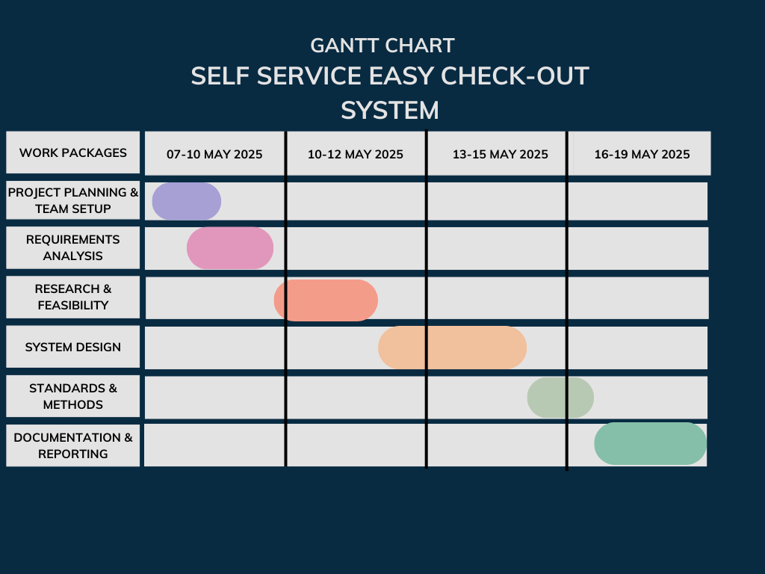

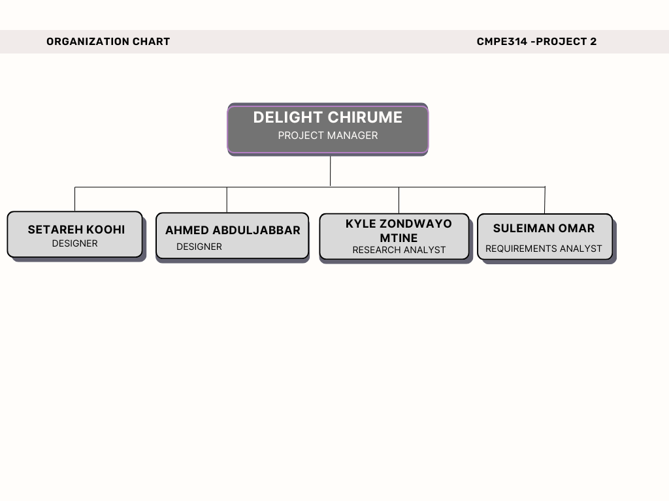
C.2
PROJECT MANAGEMENT AND ORGANISATION SCHEME
TEAM MEMBERS AND ROLES

Name | Role | Responsibilities
Delight Chirume | Project Manager | Overall coordination, scheduling, team communication, task delegation, and report submission.
Setareh Koohi | Designer | Responsible for developing the structure chart and Data Flow Diagram (DFD).
Ahmed Abduljabbar | Designer | Works alongside Setareh on all system design artifacts and ensures design consistency.
Kyle Zondwayo Mtine | Research Analyst | Collects relevant research and background on self-checkout systems and FOD methodology.
Suleiman Omar | Requirements analyst | Gathers and documents informal and formal requirements based on the given scenario.

LEVEL 0 DFD
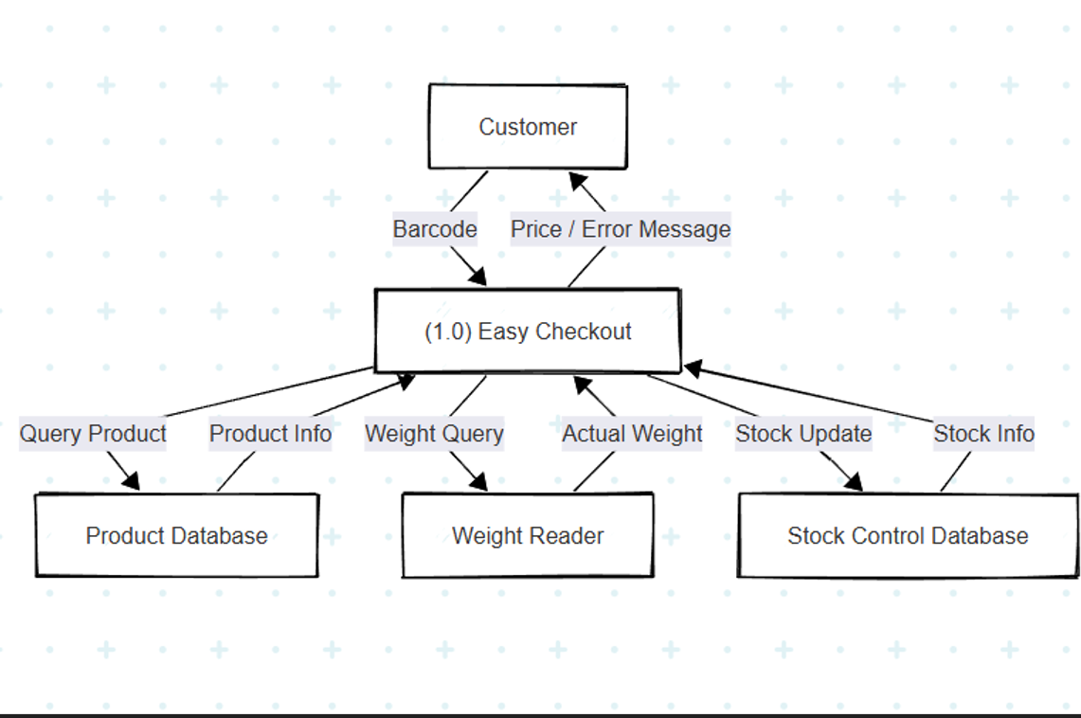
LEVEL 1 DFD
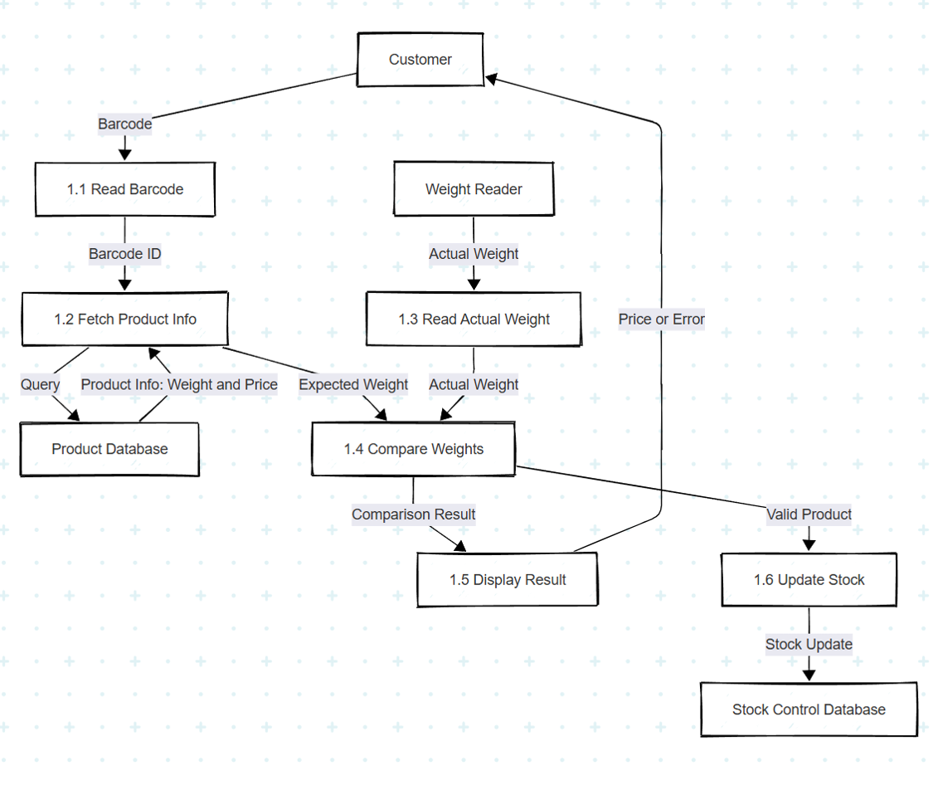
STRUCTURE CHART
